Chemistry Revision

1 Draw straight lines matching each term on the left with its definition on the right.
atom Negatively charged particle that orbits around the nucleus of an atom.
proton Pure substance made up of atoms of only one type.
neutron Central part of an atom, containing protons and neutrons.
electron Smallest piece of ordinary matter.
nucleus Positively charged sub-atomic particle.
element Organised chart of all known elements.
atomic number Atoms with the same number of protons but different numbers of neutrons.
mass number Columns of the periodic table.
atomic mass unit Metals found in group 1 of the periodic table.
isotopes The number of protons plus neutrons in the nucleus of an atom.
valence electrons Elements found in group 17 of the periodic table.
periods Used for measuring the mass of sub-atomic particles.
groups Electrons in the outermost shell.
alkali metals Rows of the periodic table.
alkaline earth metals The number of protons in the nucleus of an atom.
halogens Metals found in group 2 of the periodic table
periodic table Sub-atomic particle that has no charge.
2 Label the model of an atom shown below.

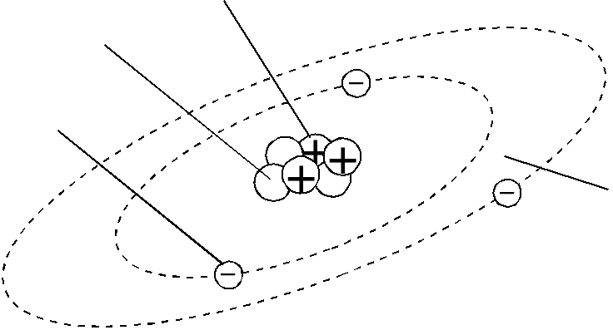

This model represents an atom of ______________________________
3 Complete this table.
Element | Symbol | Atomic number | Mass number | Number of protons | Number of electrons | Number of neutrons
helium |  | 2 |  |  |  | 2
 | N |  | 14 | 7
sodium |  |  | 23 |  |  | 12
chlorine |  |  | 35 |  | 17
 | Ca |  |  |  | 20 | 20

Complete the definitions below about atoms.

- Matter is anything that has and takes up .

- An Atom is the smallest unit of .

- Protons are the sub-atomic particles that are - charged and situated in the nucleus of the atom.

- Neutrons are the sub-atomic particles that are - charged and situated in the nucleus of the atom.

- Electrons are

- The Atomic Number is the number of

- The Mass Number is the total number of

- An Ion is a charged that has either lost or gained negatively- charged

- A Negative Ion is a charged atom that has electrons.

10. A Positive Ion is a charged atom that has electrons.

11. An Element is a pure substance that is made of only type of atom (e.g. gold, oxygen).

For each of the following reactions, write a word equation to describe the reaction.
- Barium nitrate reacts with sulphuric acid to produce barium sulphate and nitric acid.

- Calcium carbonate reacts with hydrochloric acid to produce calcium chloride, carbon dioxide and water.

- Solid aluminium hydroxide reacts with nitric acid to produce aluminium nitrate and water.

- Sodium carbonate and water are produced when sodium hydroxide reacts with carbon dioxide.

- Magnesium oxide reacts with hydrochloric acid to produce magnesium chloride and water.

- Zinc sulphate and hydrogen gas are produced when sulphuric acid is poured onto zinc.

- Calcium oxide reacts with hydrochloric acid to form calcium chloride and water.

- Aluminium oxide is formed when aluminium is burnt in oxygen.

For each of the word equations below, write a formula equation.
- Methane + oxygen gas → carbon dioxide + water

- Copper + oxygen → copper (I) oxide

- Silver + sulphur → silver sulphide

- Silver nitrate + magnesium chloride → silver chloride + magnesium nitrate

- Iron (II) sulphide + oxygen gas → Iron (II) oxide + sulphur dioxide

- Copper hydroxide + carbon dioxide → copper carbonate + carbon dioxide + water

- Sodium hydroxide + iron (II) nitrate → iron (II) hydroxide + sodium nitrate

- Aluminium + silver nitrate → aluminium nitrate + silver

- Iron (II) sulphide + hydrochloric acid → iron (II) chloride + hydrogen sulphide

- Aluminium oxide + carbon → aluminium + carbon dioxide + oxygen

- Sulphur + oxygen → sulphur dioxide

- Lead (IV) oxide + phosphoric acid → lead (IV) phosphate + water

- Ammonium chloride + calcium hydroxide → ammonia + calcium chloride + water

- Sodium chloride + sulphuric acid → hydrogen chloride + sodium sulphate

- Nitric acid + potassium hydroxide → potassium nitrate + water

- Hydrochloric acid + zinc metal → zinc chloride + hydrogen gas

- Calcium + water → calcium hydroxide + hydrogen gas
Determine the chemical names of the following ionic compounds from their chemical formulas.
 | Chemical formula | Chemical name
a | NaCl
b | PbI2
c | BaS
d | Li3N
e | Al2O3
5 Determine the chemical names of the following ionic compounds from their chemical formulas. Be careful to identify the correct charge of each cation.
 | Chemical formula | Chemical name
a | CuCl2
b | FeO
c | Fe2O3
d | MnS2
e | CrO3

6 Determine the chemical name and formula of the ionic compounds made from the following cations and anions.
 | Cation | Anion | Chemical name | Chemical formula
a | Na+ | O2-
b | Mg2+ | Cl-
c | Zn2+ | S2-
d | Al3+ | P3-
e | Al3+ | C4-
f | Cu2+ | S2-
g | Mn4+ | O2-
h | Cr6+ | Cl-
i | Fe2+ | S2-
j | Fe3+ | S2-

- What is an “Indicator”?

- Name 3 indicators.
- Litmus paper is used to test for acid or base.
Blue litmus → Red indicates the solution is ________________(acidic/basic)
Red litmus → Blue indicates the solution is ________________(acidic/basic)

- If a solution does not change the colour of the red litmus, what can you tell about this solution?
- Why is pH paper a better choice than litmus paper?

- In term of acidity, what is the difference between pH 1 and pH 5?

- Which pH indicates a neutral substance?

- Balance each of these chemical equations.

  - ____ P₄ + ____ O₂ → ____ P₂O₃
  - ____ Al + ____ HCl → ____ H₂ + ____ AlCl₃
  - ____ Pb(OH)₂ + ____ HCl → ____ H₂O + ____ PbCl₂
  - ____ N₂ + ____ H₂ → ____ NH₃
  - ____ CH₄ + ____ O₂ → ____ CO₂ + ____ H₂O
  - ____ KCl → ____ K + ____ Cl₂
  - ____ Na₃PO₄ + ____ CaCl₂ → ____ NaCl + ____ Ca₃(PO₄)₂

- Name three properties of acids and three properties of bases.

- Explain what the term ‘half-life’ means.

- What are the three types of radioactive decay? What particles are emitted during each?

- What is an isotope? What is a radioisotope?

- Draw the electron configuration for the following:

  - Sodium Atom

  - Phosphorus Atom

  - Magnesium Ion

  - Chloride Ion

- Explain the difference between an exothermic and endothermic reaction.

- What is the difference between ionic and covalent compounds? Provide an example of each.

Valency List
POSITIVE IONS |  |  |  |  |  | NEGATIVE IONS
Name | Symbol |  | Name | Symbol |  | Name | Symbol |  | Name | Symbol
Hydrogen | H⁺ |  | Cobalt | Co²⁺ |  | Fluoride | F⁻ |  | Sulfate | SO₄²⁻
Sodium | Na⁺ |  | Zinc | Zn²⁺ |  | Chloride | Cl⁻ |  | Carbonate | CO₃²⁻
Potassium | K⁺ |  | Lead (II) | Pb²⁺ |  | Bromine | Br⁻ |  | Nitride | N³⁻
Silver | Ag⁺ |  | Tin (II) | Sn²⁺ |  | Iodide | I⁻ |  | Phosphide | P³⁻
Copper (I) | Cu⁺ |  | Copper(II) | Cu²⁺ |  | Hydroxide | OH⁻ |  | Phosphate | PO₄³⁻
Lithium | Li⁺ |  | Aluminium | Al³⁺ |  | Nitrate | NO₃⁻
Iron (II) | Fe²⁺ |  | Chromium(III) | Cr³⁺ |  | Oxide | O²⁻
Calcium | Ca²⁺ |  | Iron (III) | Fe³⁺ |  | Sulfide | S²⁻
Barium | Ba²⁺ |  | Tin (IV) | Sn⁴⁺
Magnesium | Mg²⁺ |  | Lead (IV) | Pb⁴⁺
Nickel | Ni²⁺

